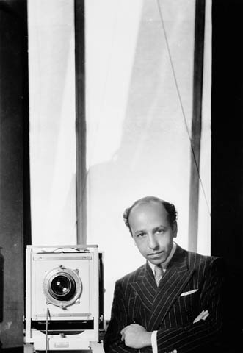
Yousuf Karsh -Winston Churchill, The Roaring Lion”
Karsh was a master of studio lights. One of Karsh's distinctive practices was lighting the subject's hands separately. He photographed many of the great and celebrated personalities of his generation. Throughout most of his career he used the 8×10 bellows Calumet (1997.0319) camera, made circa 1940 in Chicago.[9] Journalist George Perry wrote in the British paper The Sunday Times that "when the famous start thinking of immortality, they call for Karsh of Ottawa."
Karsh had a gift for capturing the essence of his subject in the instant of his portrait. As Karsh wrote of his own work in Karsh Portfolio in 1967, "Within every man and woman a secret is hidden, and as a photographer it is my task to reveal it if I can. The revelation, if it comes at all, will come in a small fraction of a second with an unconscious gesture, a gleam of the eye, a brief lifting of the mask that all humans wear to conceal their innermost selves from the world. In that fleeting interval of opportunity the photographer must act or lose his prize."
Karsh said "My chief joy is to photograph the great in heart, in mind, and in spirit, whether they be famous or humble." His work is in permanent collections of the National Gallery of Canada, New York's Museum of Modern Art and Metropolitan Museum of Art, George Eastman House International Museum of Photography and Film, Bibliotheque nationale de France, the National Portrait Gallery in London, the National Portrait Gallery of Australia and many others. Library and Archives Canada holds his complete collection, including negatives, prints and documents. His photographic equipment was donated to the Canada Science and Technology Museum in Ottawa.
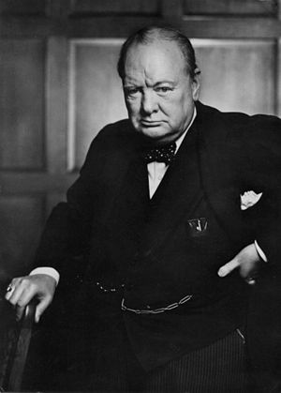
Karsh published 15 books of his photographs, which include brief descriptions of the sessions, during which he would ask questions and talk with his subjects to relax them as he composed the portrait. Some famous subjects photographed by Karsh were Field Marshal Lord Alanbrooke, Muhammad Ali, Marian Anderson, W. H. Auden, Joan Baez, Prince Bernhard of Lippe-Biesterfeld, Zulfiqar Ali Bhutto, Humphrey Bogart, Alexander Calder, Pablo Casals, Fidel Castro, Madame Chiang Kai-Shek, Winston Churchill, Joan Crawford, Ruth Draper, Albert Einstein, Dwight Eisenhower, Princess Elizabeth, Robert Frost, Clark Gable, Indira Gandhi, Grey Owl, Ernest Hemingway, Audrey Hepburn, Pope John Paul II, Chuck Jones, Carl Jung, Helen Keller and Polly Thompson, Grace Kelly, Jacqueline Kennedy, John F. Kennedy, Peter Lorre, The Marx Brothers, Pandit Nehru, Georgia O'Keeffe, Laurence Olivier, General Pershing, Pablo Picasso, Pope Pius XII, Prince Rainier of Monaco, Paul Robeson, the rock band Rush, Albert Schweitzer, George Bernard Shaw, Jean Sibelius, Pierre Elliott Trudeau, Andy Warhol, and Frank Lloyd Wright.
The story is often told of how Karsh created his famous portrait of Churchill during the early years of World War II. Churchill, the British prime minister, had just addressed the Canadian Parliament and Karsh was there to record one of the century's great leaders. "He was in no mood for portraiture and two minutes were all that he would allow me as he passed from the House of Commons chamber to an anteroom," Karsh wrote in Faces of Our Time. "Two niggardly minutes in which I must try to put on film a man who had already written or inspired a library of books, baffled all his biographers, filled the world with his fame, and me, on this occasion, with dread."
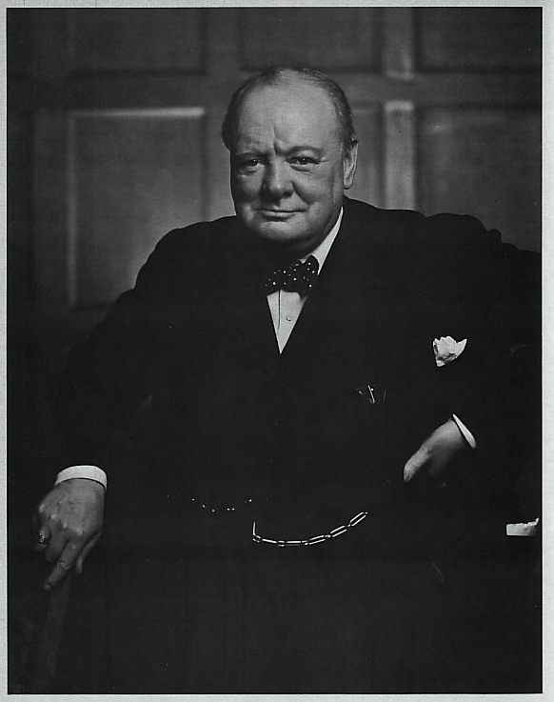
Churchill marched into the room scowling, "regarding my camera as he might regard the German enemy." His expression suited Karsh perfectly, but the cigar stuck between his teeth seemed incompatible with such a solemn and formal occasion. "Instinctively, I removed the cigar. At this the Churchillian scowl deepened, the head was thrust forward belligerently, and the hand placed on the hip in an attitude of anger."
The image captured Churchill and the Britain of the time perfectly — defiant and unconquerable. Churchill later said to him, "You can even make a roaring lion stand still to be photographed." As such, Karsh titled the photograph, The Roaring Lion.
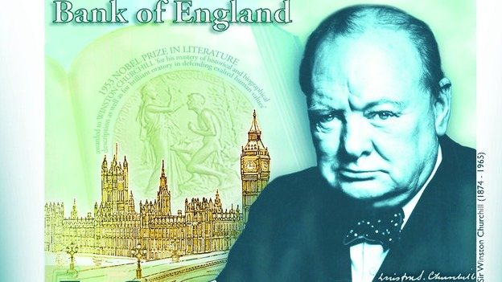
However, Karsh's favourite photograph was the one taken immediately after this one where Churchill's mood had lightened considerably and he is shown much in the same pose, but smiling. It was announced on 26 April 2013 by the Bank of England that the more well-known image would be used on the new £5 note, to be issued in 2016.

Answer the questions and underline where the answers are found in the reading. Do an image search by going google images and put in Karsh and then one of the names of famous people Karsh Photographed. Make sure it is a Karsh Photograph of them. Do 12 of the people.
- What was one of Karsh’s distinct practices?

- Why did the famous call on Karsh?

- What was Karsh’s gift?

- What did Karsh write about people?

- What was Karsh joy?

- Why did Karsh call the picture of Churchill, “the Roaring Lion”?

